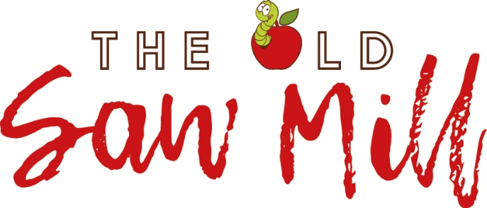

The Old Saw Mill Business Sponsorship Application Form

My company wishes to be a business sponsor of The Old Saw Mill CBS to the value of:

Sponsorship Level | Amount £ per annum | Tick
Golden Delicious | £2000
Cox’s Orange Pippin | £1000
Russet | £500
Other

Please arrange payment by bank transfer to
20-82-13 93834549 (The Old Saw Mill CBS Ltd)
and send an email confirming payment details to: info@theoldsawmill.org

Organisation Details
Organisation Name
Contact Name
Address
Postcode
Email
Telephone no

Agreement
- I wish to become a Corporate Sponsor of The Old Saw Mill CBS Limited
- I understand that the Board of Directors of The Old Saw Mill CBS Limited may reject this application, and are not obliged to say why it has been rejected.
- I am happy for my company’s name to be used in official documents to publicise my support for the work of the Old Saw Mill.
- I consent to receiving communications by email from the Old Saw Mill

Data Protection
The data provided by you on this form will be stored by the Old Saw Mill and will be used only for The Old Saw Mill CBS purposes. For further information about how The Old Saw Mill CBS Ltd. handles your data please see the Privacy Notice on our website: www.oldsawmill.org.

Communication
The Old Saw Mill will send you information and our newsletter by email. You can opt-out at any time by clicking the link at the bottom of any email or writing to info@theoldsawmill.org.
Signature:

Name in print:

Date:

Please email your completed application form to: info@theoldsawmill.org
Or send it to: The Old Saw Mill, Back River Street, Congleton CW12 1HJ

